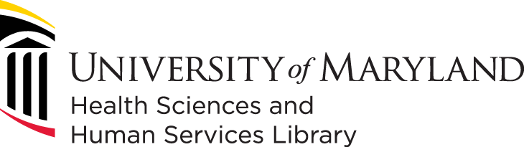

Student Intern – Oral History and Community Archives

The Health Sciences and Human Services Library (HSHSL) of the University of Maryland, Baltimore (UMB) welcomes current students or recent graduates of library science, information science, history, or related programs to apply for an engaging, dynamic, and flexible internship experience.
The internship is funded through an Access & Engagement Innovation Grant received from UMB’s Office of Inclusive Excellence and Institutional Effectiveness. The purpose of the internship is to help the HSHSL, and partners create the “Preserving UMB Voices: A Community‑Driven Oral History Initiative.” The intern will work with professional librarians, museum curators, and academic faculty and staff for six months.

The Intern may help with:
- Drafting Oral History Questions
- Researching Oral History Interviewees
- Conducting Oral History Interviews
- Editing Oral History Interviews
- Transcribing Oral History Interviews
- Community outreach

Required Qualifications:
- Enrolled in or have graduated within last 2 years from a Graduate-level program in Library and/or Information Science, History, or related field.
- An In-person or virtual interview.
- Excellent communication skills.
- Commitment to diversity, inclusion, and equity.
- Adheres to UMB’s Core Values Core Values

Preferred Qualifications:
- Interest in health sciences and human services.
- Experience with Oral History interviews or projects
- Interest in archives, library special collections, or museums

Application Process:
Interested candidates must submit:
- A current CV/resume documenting your work history.
- A cover letter
- List of 3 references

Please send these documents to Tara Wink, twink@hshsl.umaryland.edu. Priority consideration given to materials received by Friday, May 1, 2026.

Payment
This is a paid internship opportunity. Due to Maryland state limitations, the HSHSL can only pay interns living in the contiguous states of Maryland (Pennsylvania, Virginia, West Virginia, Delaware, and Washington D.C.). If seeking academic credit, interns will need to adhere to the policy of the credit-granting school for paid internships. Payment is at MD state minimum wage.

Overview of the Health Sciences and Human Services Library:
The University of Maryland, Baltimore campus is located in downtown Baltimore, blocks from Orioles Park at Camden Yards, Raven's Stadium, and the Inner Harbor, a recreational waterfront destination. Baltimore City and the surrounding metropolitan area are noted for high quality-of-life indicators offering historic parks, great neighborhoods, and world-famous art collections, museums, theaters, and symphony orchestras.
The HSHSL is one of the largest health sciences libraries in the United States with a record of user-centered innovative services and programs. Fifty-six FTE employees including 25 faculty librarians staff the library. Our attractive and vibrant facility, which opened in 1998, serves as a hub for collaboration and learning with resources, programs, and tools that promote discovery, creativity, and innovation. The HSHSL also serves as the headquarters for the Network of the National Library of Medicine (NNLM), Region 1.
The HSHSL serves the schools of Dentistry, Medicine, Nursing, Pharmacy, Social Work, and the Graduate School. It supports 7,200 students and nearly 7,900 faculty and staff members.
UMB is an Equal Opportunity/Affirmative Action employer. All qualified applicants will receive consideration for employment without regard to sex, gender identity, sexual orientation, race, color, religion, national origin, disability, protected Veteran status, age, or any other characteristic protected by law or policy.
If you anticipate needing a reasonable accommodation for a disability under the Americans with Disabilities Act (ADA) during any part of the application process, please submit a UMB Job Applicant Accommodation Request. For questions about ADA requests for reasonable accommodations, you may also contact HRDiversity@umaryland.edu.

